**ASSIGNMENT - 2**

**CSP - 554 BIG DATA TECHNOLOGIES**

**Question # 10**

Execute the following hdfs command and take a screen snapshot of the names of the files or

directories that are listed (also indicating which is a file and which a directory):

**Command:** hadoop fs -ls /

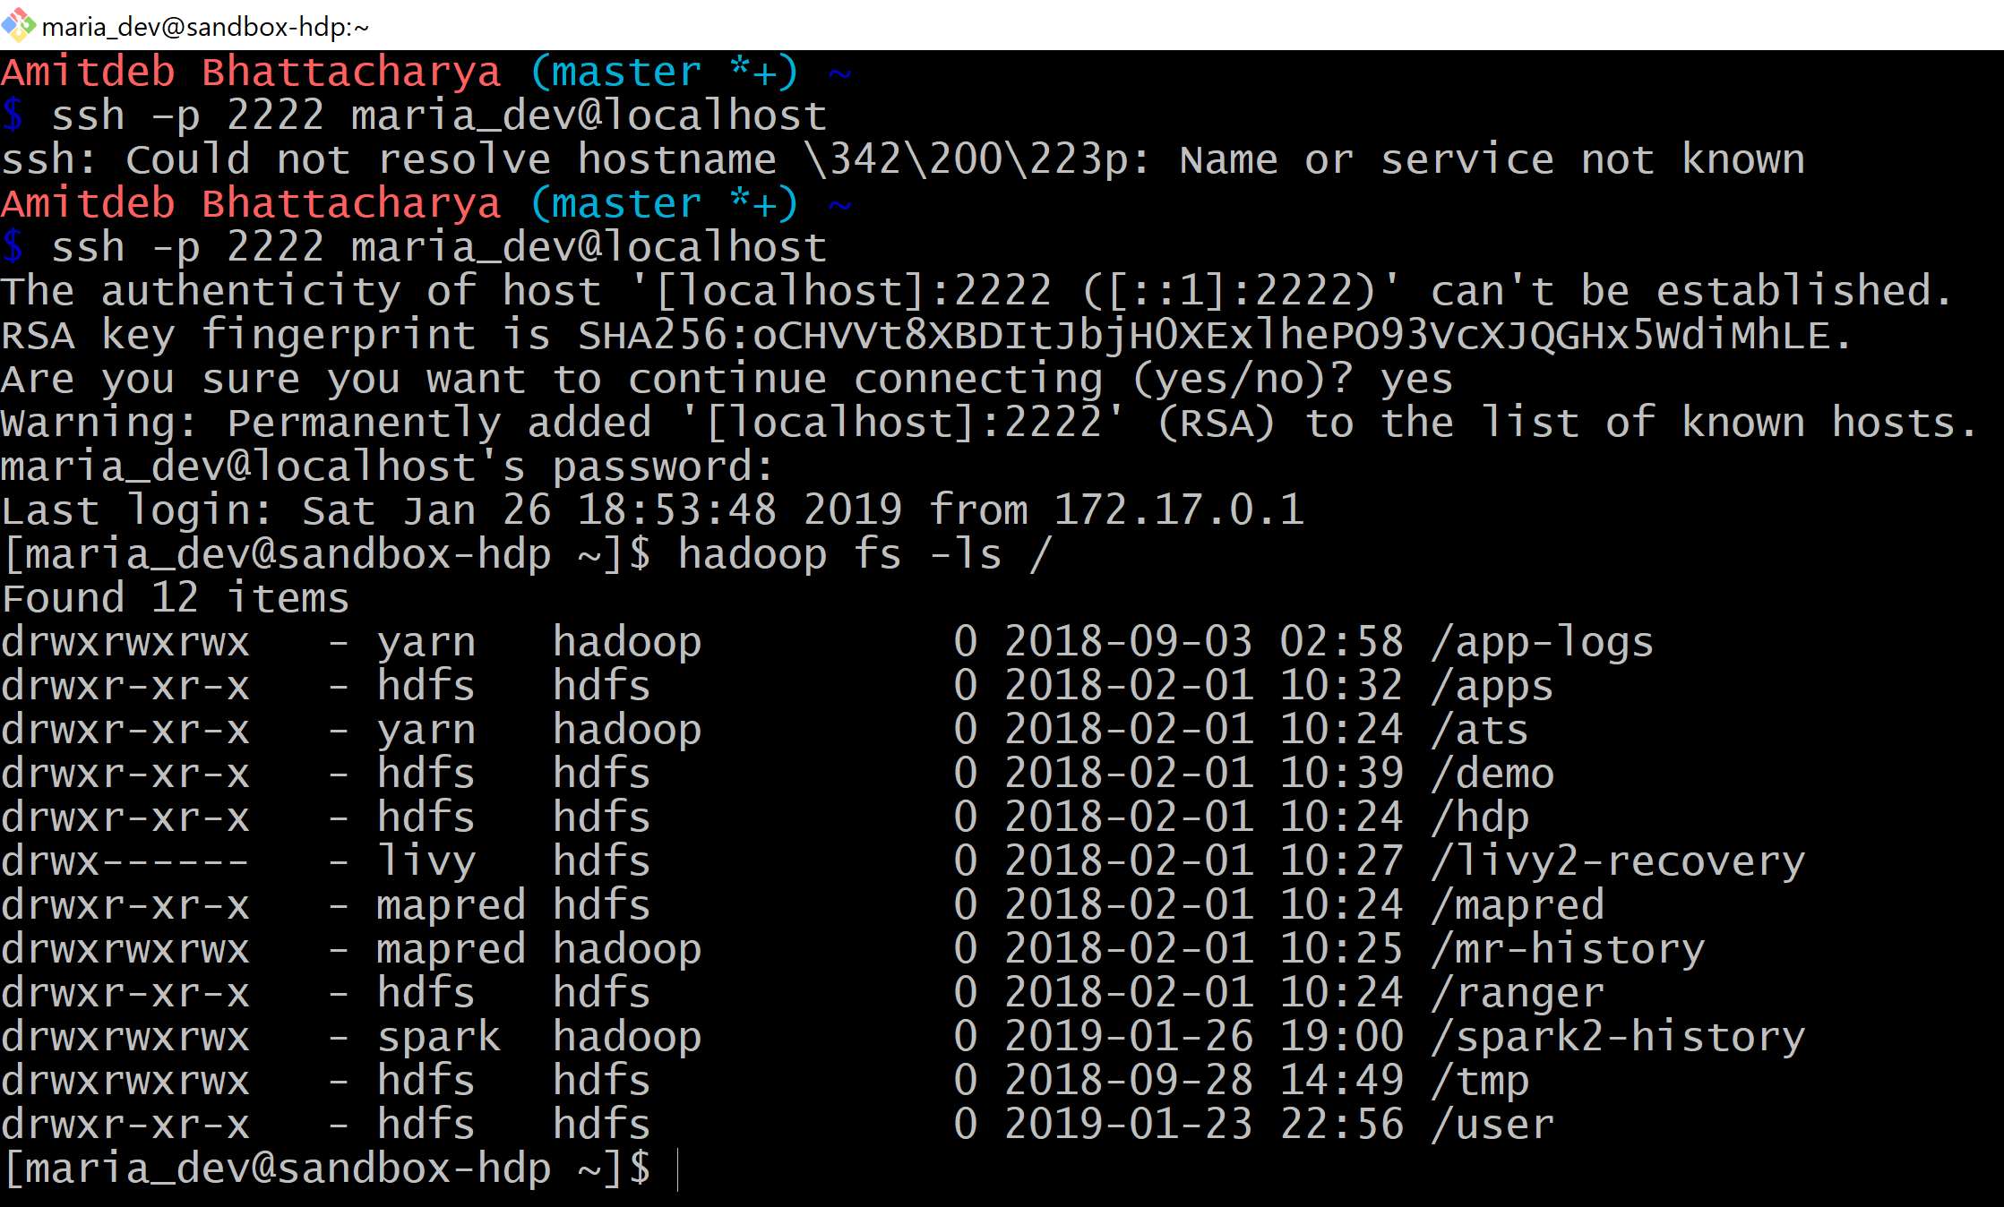

All the items are directories and there are no files.

**Question # 11**

Execute a command (you needed to figure out which one) to list the files and subdirectories

under the hdfs directory listed below:

/user

Write down the command you executed and also take a screen snapshot of names of the

files or directories that are listed.

**Command:** hadoop fs -ls /user

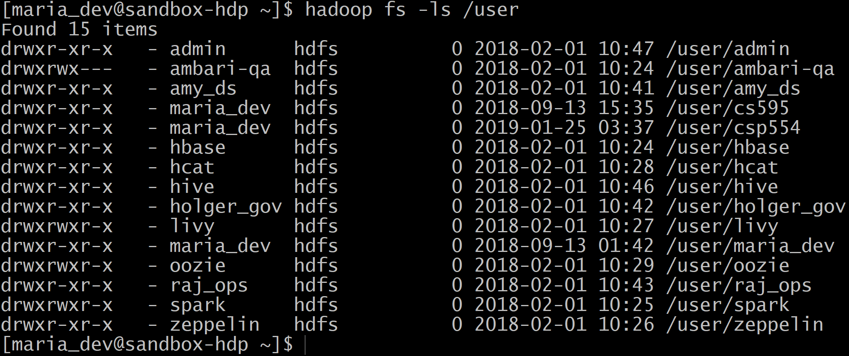

**Question # 12**

Execute a command to create the following directory:

/user/csp554/<yournamenospaces>

**Command:** hadoop fs -mkdir /user/csp554/amitdeb

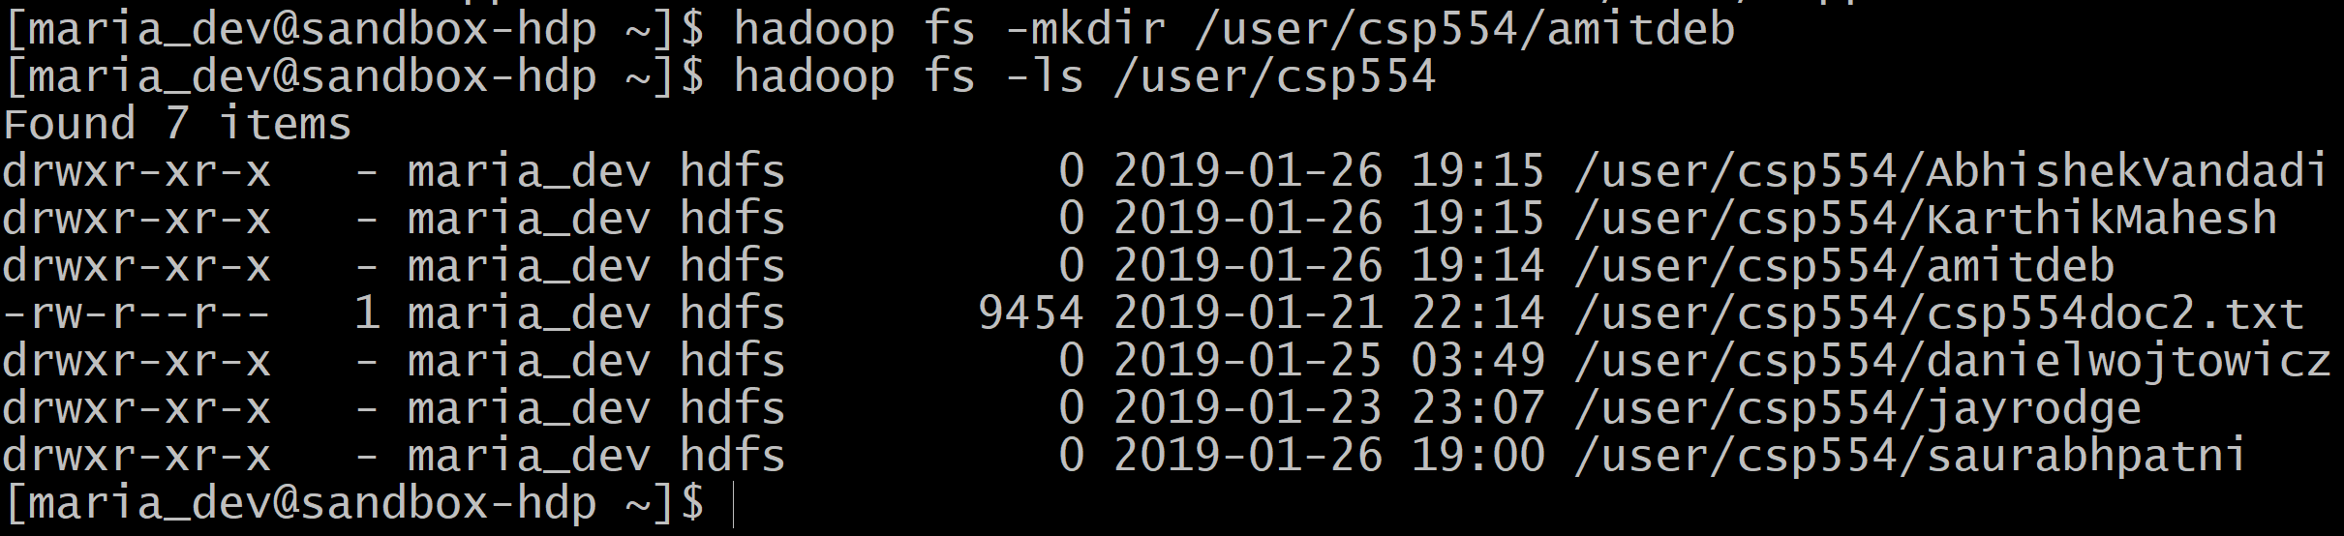

**Question # 13**

Execute a command that copies a given local file (that I already created for you) to the

given hdfs directory:

**Local file:** /home/maria_dev/csp554doc.txt

HDFS directory: /user/csp554/<yournamenospaces>

**Command:** hadoop fs -copyFromLocal /home/maria_dev/csp554doc.txt

/user/csp554/amitdeb

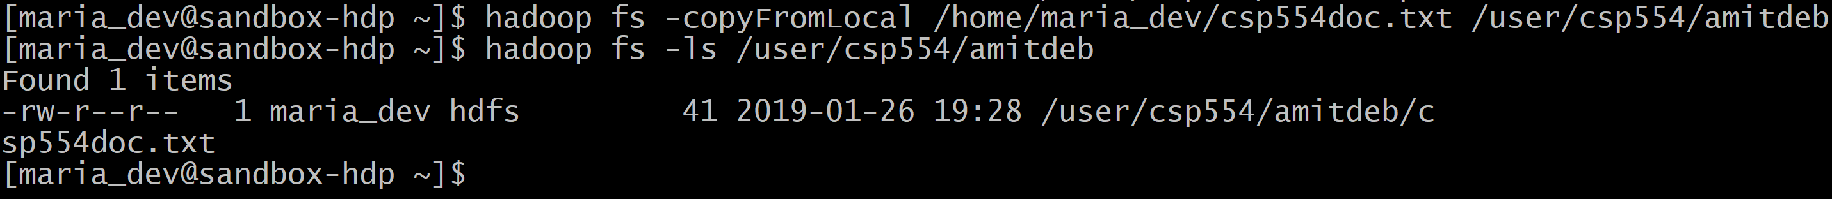

**Question # 14**

Copy the given file from one hdfs directory to another hdfs directory and write down the

command

**Source hdfs file:** /user/csp554/csp554doc2.txt

**Destination HDFS directory:** /user/csp554/<yournamenospaces>

**Command:** hadoop fs -cp /user/csp554/csp554doc2.txt /user/csp554/amitdeb

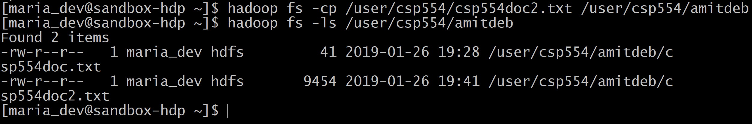

**Question # 15**

Execute a command that copies the firstname_lastname.txt file to the given hdfs directory:

**Local file:** /home/maria_dev/firstname_lastname.txt

**Command:** hadoop fs -moveFromLocal /home/maria_dev/amitdeb_bhattacharya.txt

/user/cs595/amitdeb

